Affiliated to Farnsfield Preschool – www.farnsfieldpreschool.org  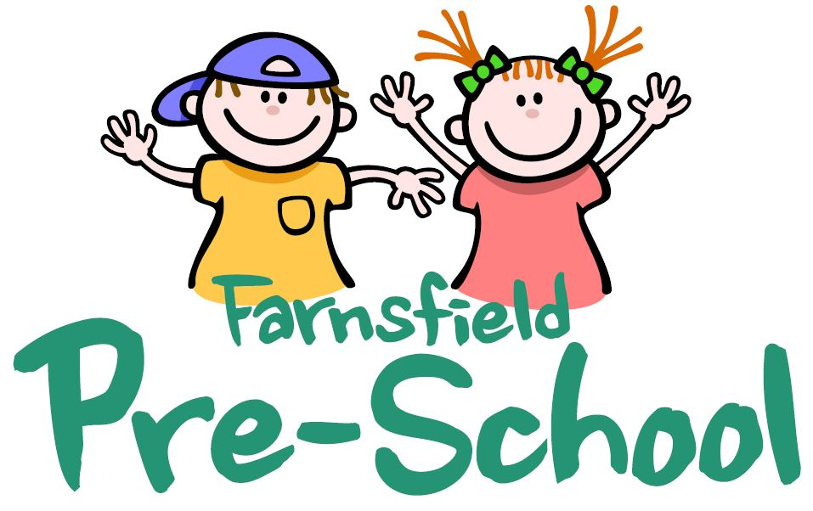  Charity Number: 1022276 | 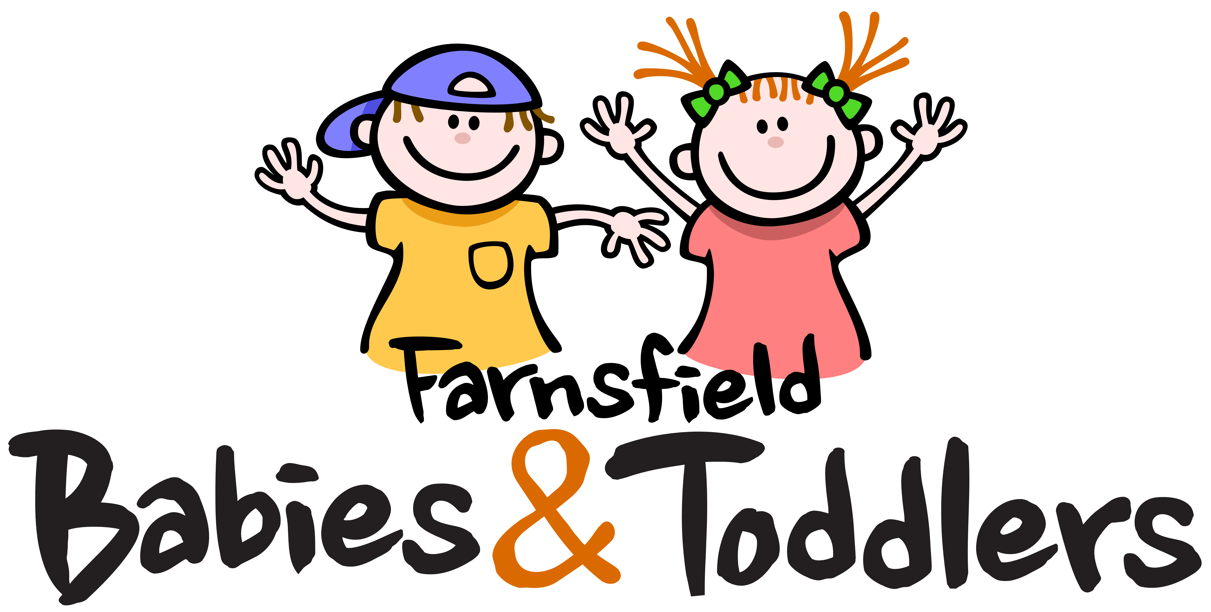  Welcome to Babies & Toddlers. We are a friendly and welcoming group for children aged 0–5 years. We run every Thursday 9–11am, during term time, in the Upper Village Hall in Farnsfield. We are affiliated with Farnsfield Pre-School, a registered charity, based on Chapel Lane which is run by a voluntary Committee.  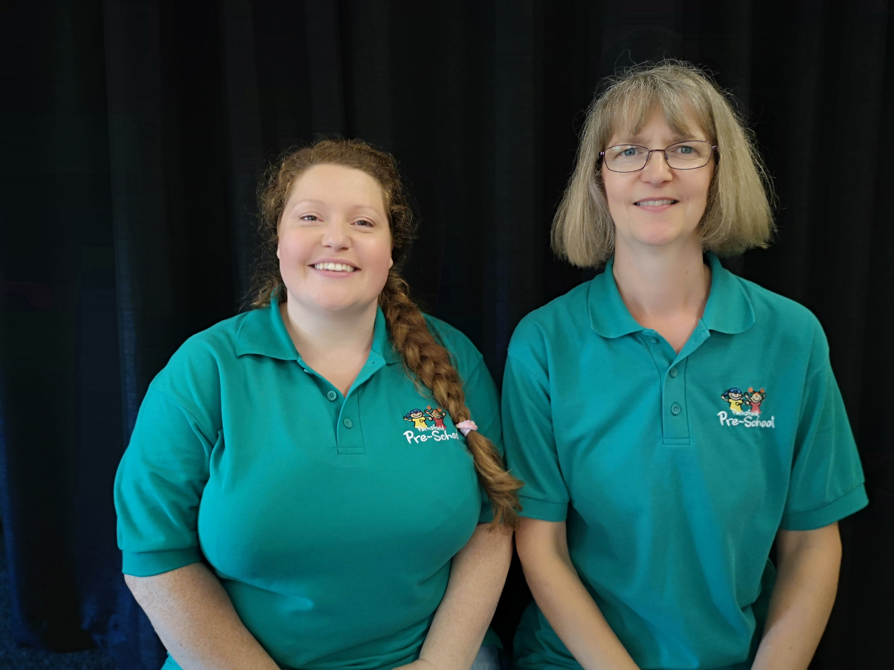  We employ 2 members of staff, Zena & Emma W. They are happy to answer any questions or queries. We also welcome any suggestions which you feel may improve our group.
We charge £2 per session per family (first session free) which is based upon 2 children and 1 adult. We charge 50p per additional child or adult to cover costs.  Upon arrival at the session we ask that you sign in at the door and pay the relevant contribution. Pushchairs are stored at the back of the room. Toys and activities are available including a baby area and craft table.  Approximately an hour into the session drinks and snacks will be served for the children. A hot drink is also served for the adults from the hatch. Should you require any additional hot drinks during the session these are available at a cost of 50p per drink.  Towards the end of the session we would appreciate any assistance you are able to give in tidying the toys away and ask that they are placed on the stage.  We generally finish the session off with a story/singing on the coloured mats.  Your Data  We can confirm that your registration form will be held by us for information purposes until your youngest child starts school. If you have requested to be included on our text list, your number will remain, again until your youngest child starts school. Should you want to be removed from the text list prior to this time please do not hesitate to contact us via our Facebook page, advising the toddler staff or email: farnsfieldpreschool@btinternet.com. We are fully compliant with GDPR. | Notices  - There are no facilities for the disposal of nappies and therefore any dirty nappies should be taken home with you.  - We remind you to keep hot drinks out of arms reach of the children.  - When leaving the session please make sure that the door is shut behind you.  - Children and Toddlers remain the responsibility of the adult who brought them at all times.  - If your child has any food allergies and/or intolerances please advise a member of staff.  - Should you wish your child to attend our Pre-School please see our Prospectus near the door and complete a Waiting List form.    - Please like our Facebook page to keep up to date with any news – Farnsfield Babies & Toddlers.

