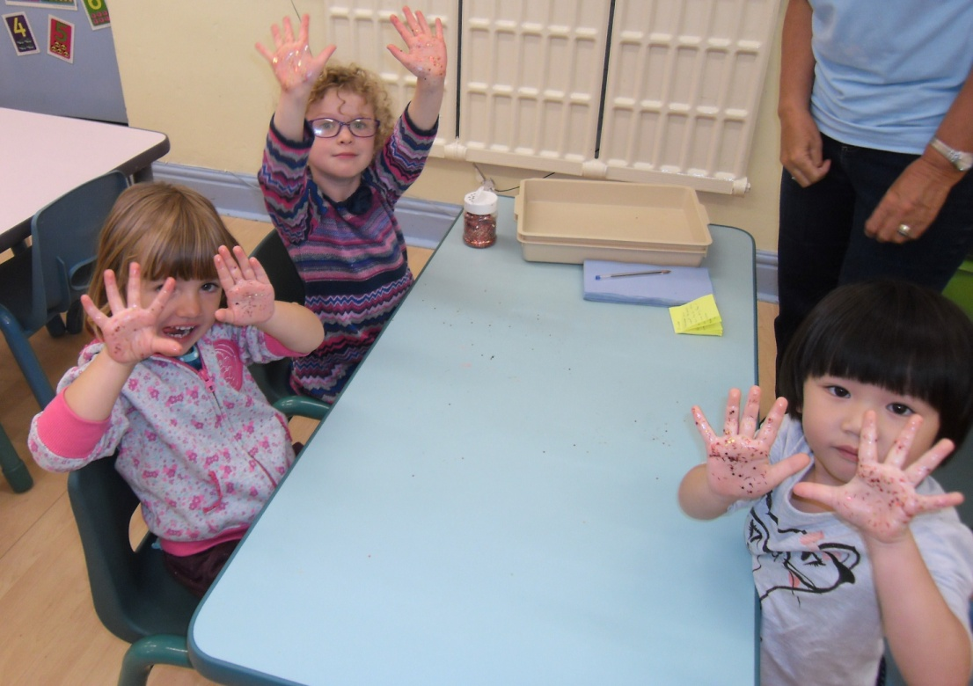
Glitter germs
Area of Learning and Development: - Physical
Health and self-care Shows some understanding that good practices with regard to hygiene can contribute to good health.
Using glitter to represent germs we shook hands with each other to show how easily it is to spread germs.
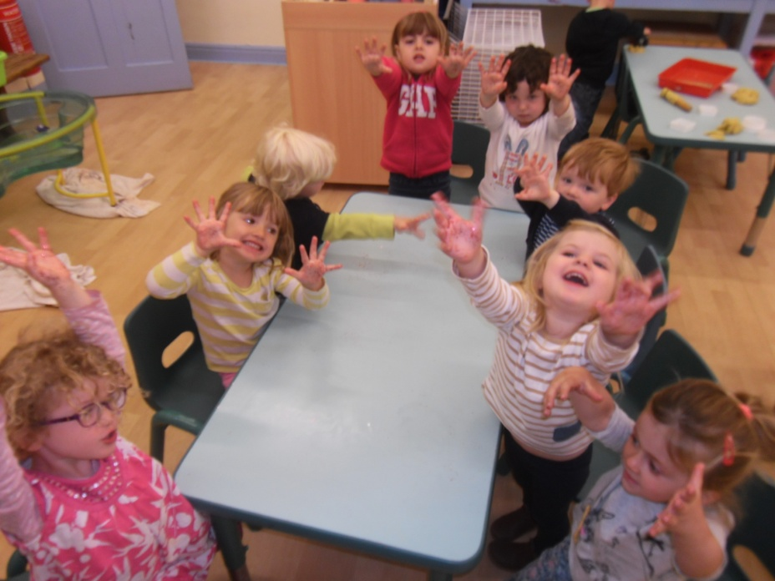
Glitter germs
Area of Learning and Development: - Physical
Health and self-care Shows some understanding that good practices with regard to hygiene can contribute to good health.

Glitter germs
Area of Learning and Development: - Physical
Health and self-care Shows some understanding that good practices with regard to hygiene can contribute to good health.
Using glitter to represent germs we shook hands with each other to show how easily it is to spread germs.
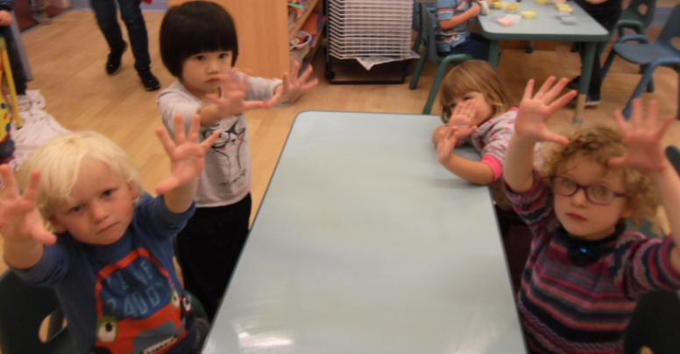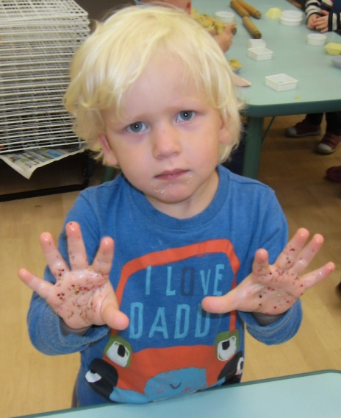

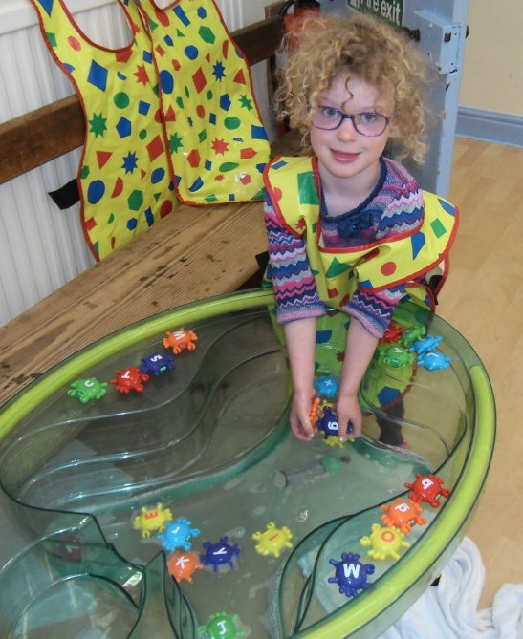
Reading
Links sounds to letters, naming and sounding the letters of the alphabet.

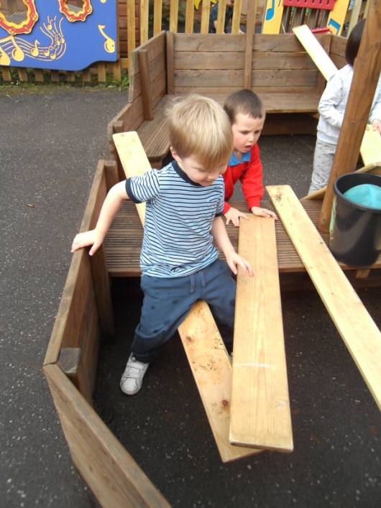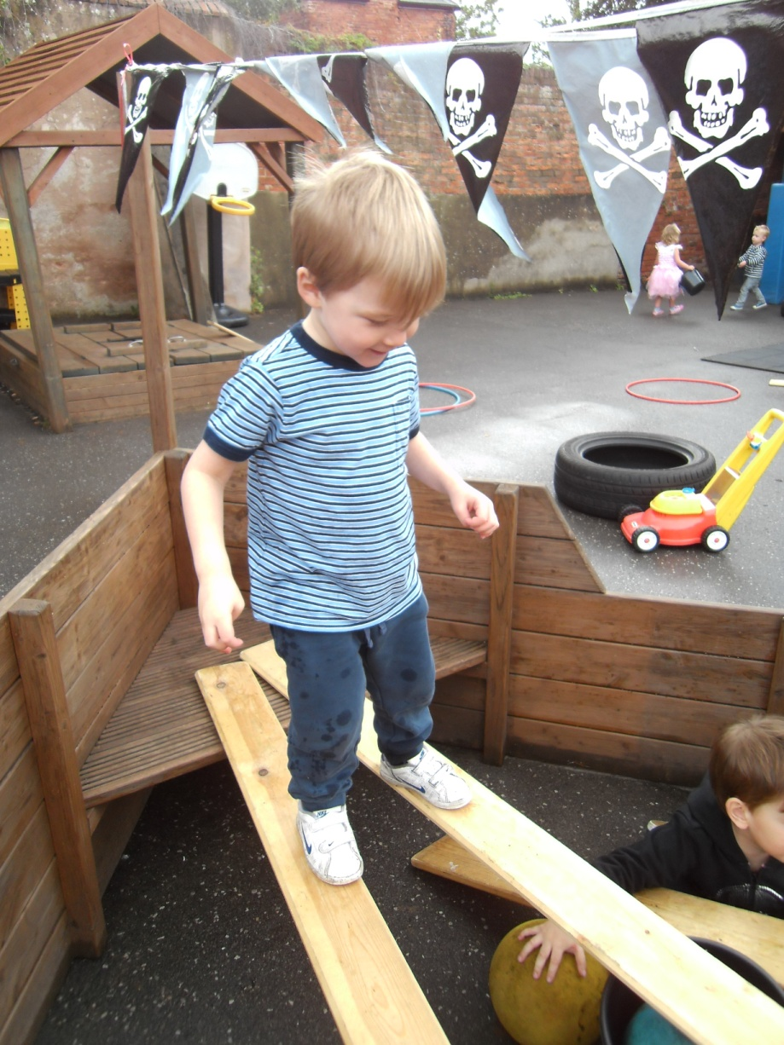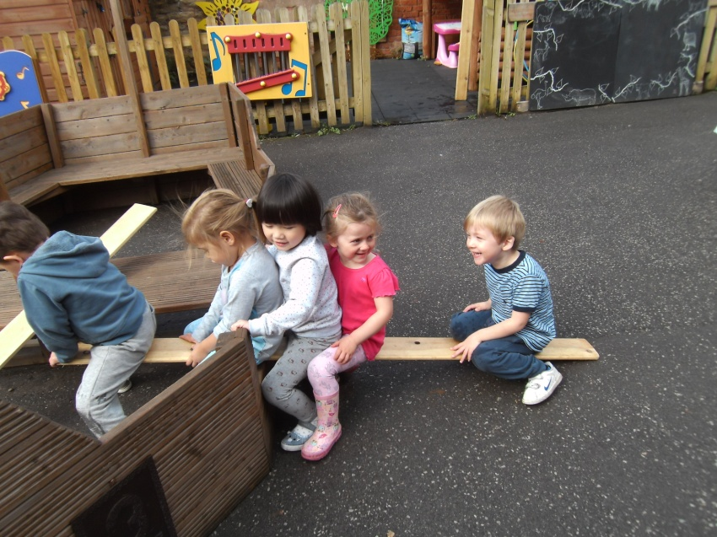
Willing to have a go
Taking a risk engaging in new experiences, pretending objects are things from experiences
Experiments with different ways of moving. Showing a good sense of balance.
Seeks out others to share experiences.
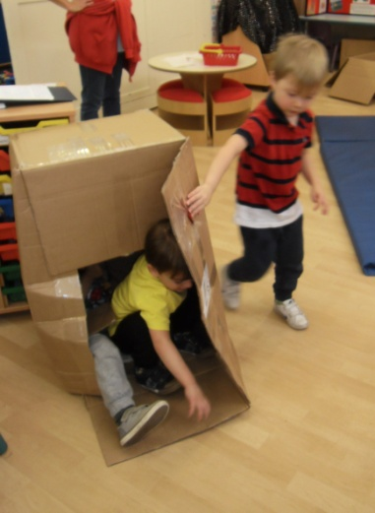.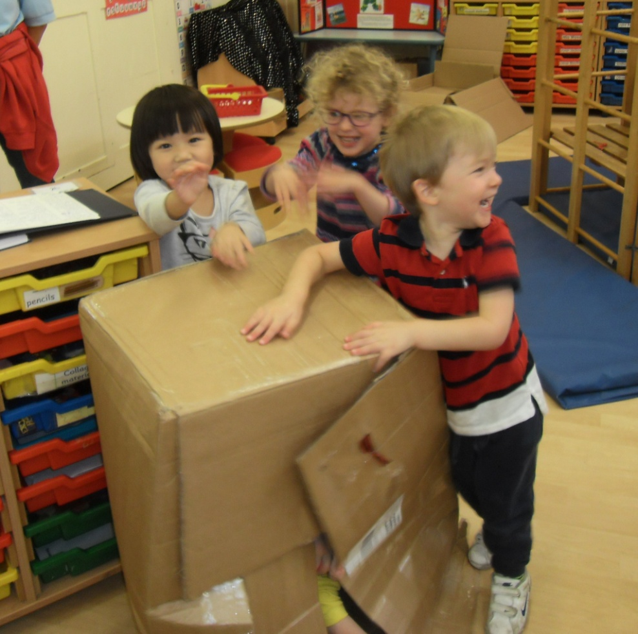 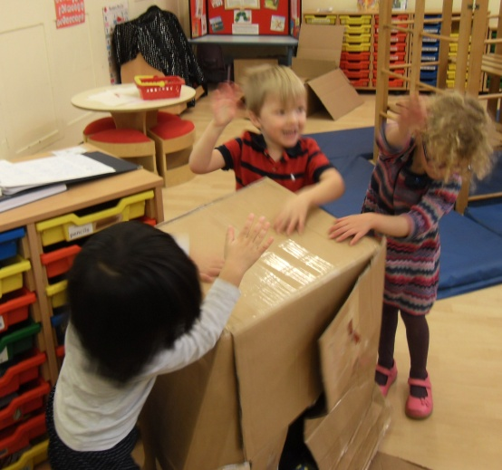

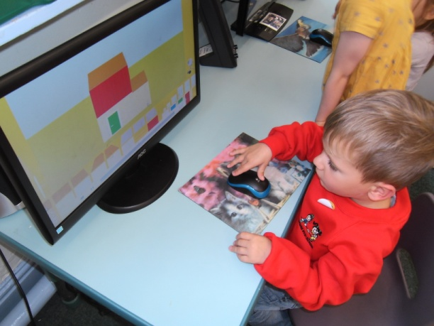
Technology
Seeks to acquire basic skills in turning on and operating some ICT equipment.

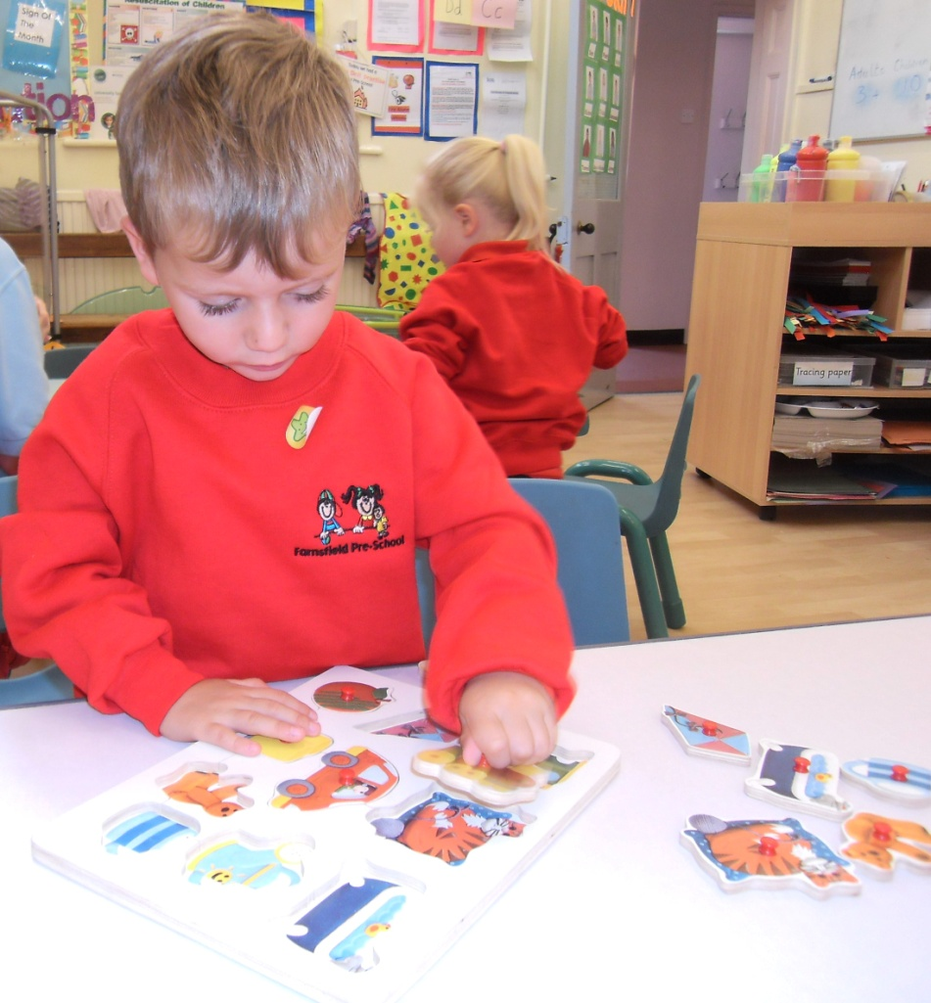
Shape, space and measure Notices simple shapes and patterns in pictures.

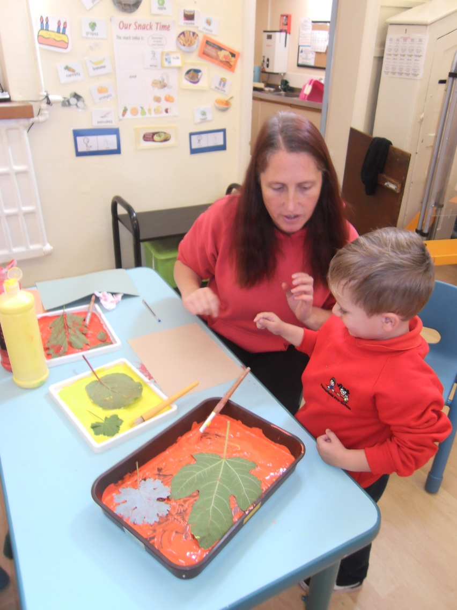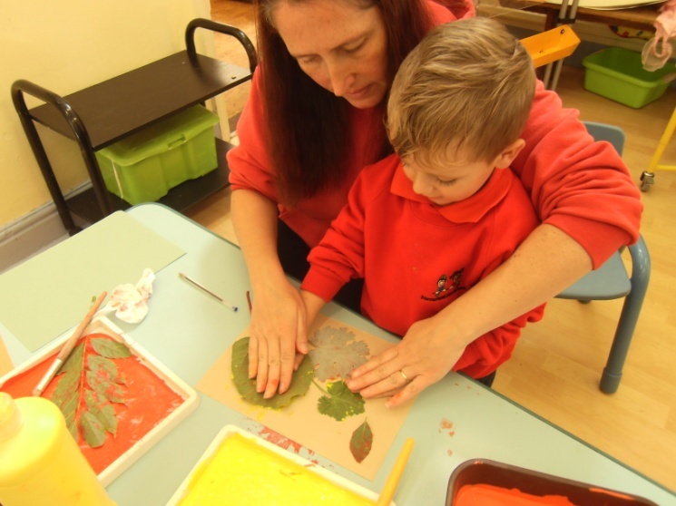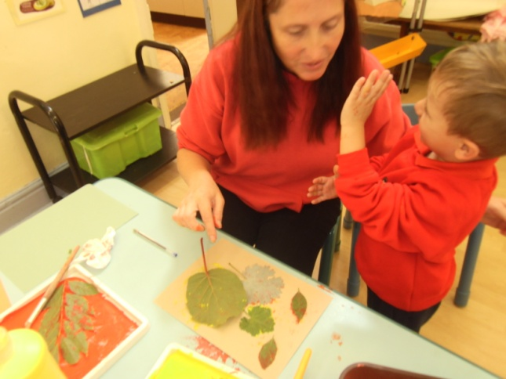
Leaf Printing
Exploring and using media and materials Experiments with blocks, colours and marks.
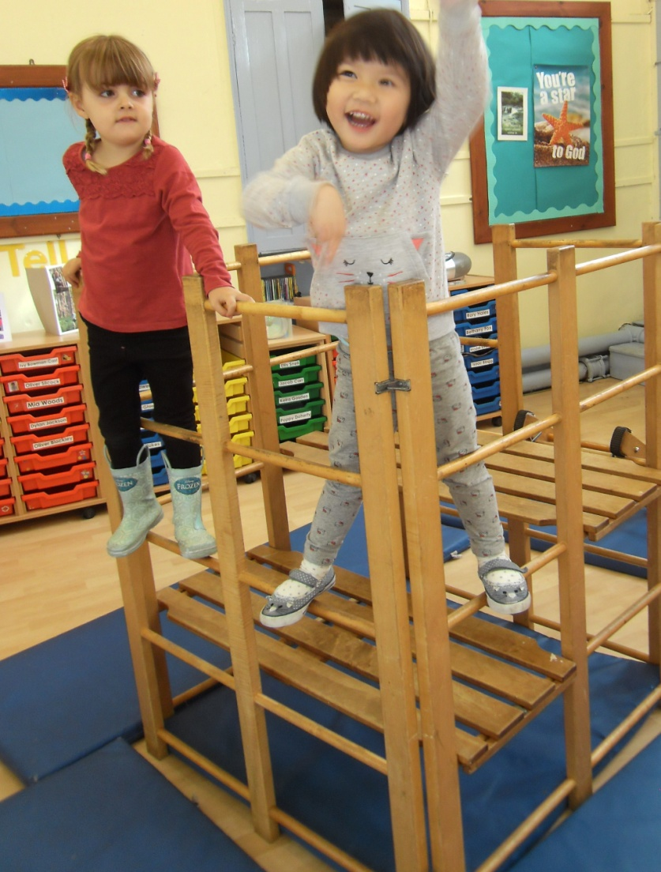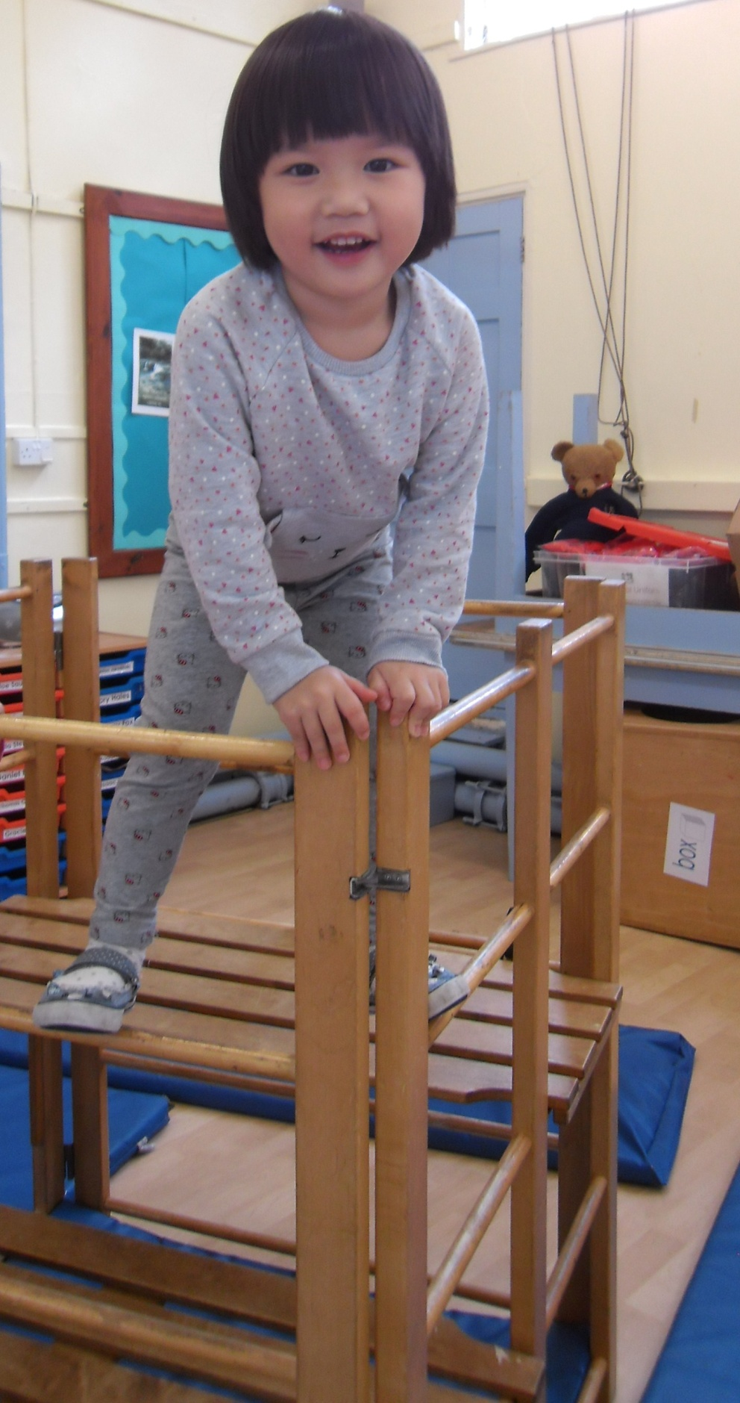
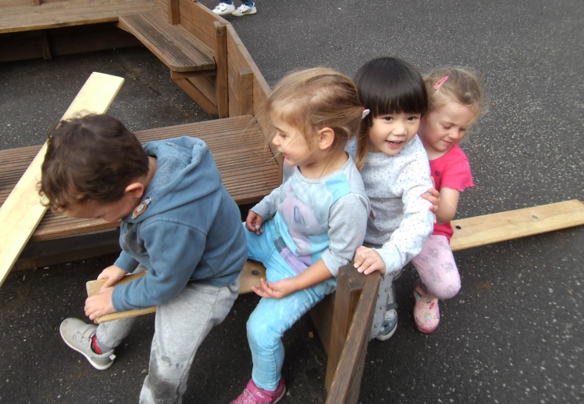
Seeks out others to share experiences. Experiments with different ways of moving.
Pretending objects are things from experiences

